It is Our celebration of town’s day.

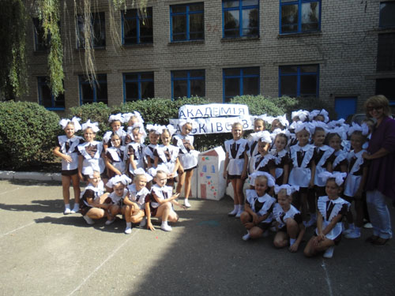

My native town is Pavlograd. I was born here and I’ve been living for all my life. Pavlograd is not large but beautiful town near Dnipropetrovs’k. Pavlograd is relatively young town: it was founded in 1784 by Ukrainian cossack D. Khyzhniak. The town
Just for fun: The Autumn Kiss.

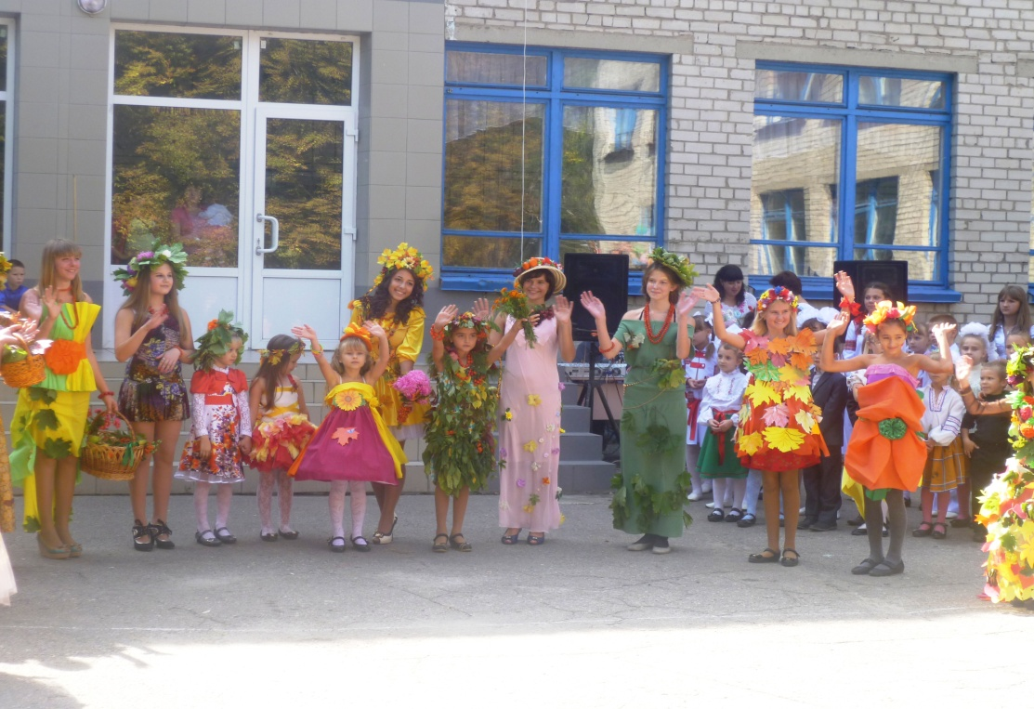

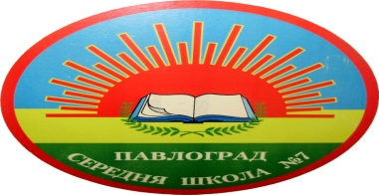

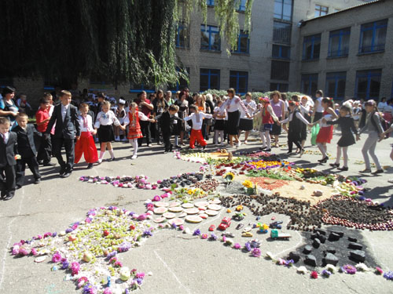

was named after the son of Kateryna II.
Every year at the school yard we’ve got a real holidays devote to Day of Our Town. In this year the pupils of our school have possibility to take part in different contests and sport

Editor: English teacher Elena Kovtun
Creative group Lukerevas Tetiana, Mykola Horhola,Marharyta Oleksandr Dorofeev,Illia Polishko

competitions. This festival of Ukrainian entertainment was

called “Veresnevyi Yarmarok”.
I’d like to notice that children of our school are very talented, creative and have outstanding abilities. They always participate in different school events.
By Lukerevas Tetiana, 9A

In the beauty of the endless,
crimson sunrise
That makes me feel so warm
I am drowning my
sorrow and my pain
But I'm feeling the
season now change
Feel the winds blowing
harder, tearing my eyes
By the dusk getting colder,
summer now dies
All alone with the
midnight, embraced by fall
And the fire of the
Moonlight Burn us all
The autumn sky shines so red
And all I loved is dead

Dnepropetrovsk, Pavlograd
Phone: (056) 32-3-01-57
e-mail: sc_7_pv@ukr.net

Англомовна газета Павлоградської загальноосвітньої школи І – ІІІ ступенів № 7
I S S U E # 6

- What news shall we get from this issue of “School Rainbow” ?

-Why “School Rainbow”
-Why “School Rainbow”
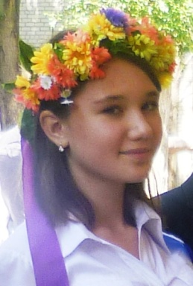
-This issue of “School Rainbow” as usual tells us about different events from our school life. It tells about Start of New School Year, Celebration of Day of our Town etс. other. Leavers’ Meeting and other interesting things

Back to school again!

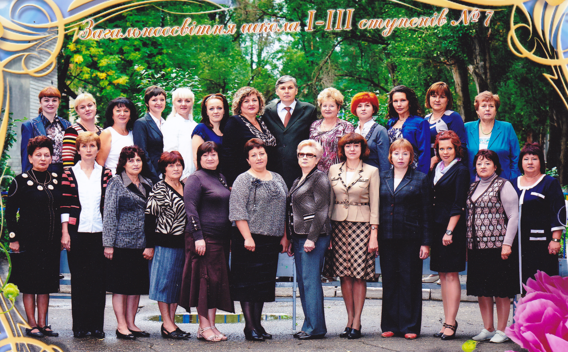

Our motto: Not to observe but to create.
There are 450 pupils in our school. Some of them participate in district and regional Olympiads and Ukrainian contests. We have a good tradition to reward

teachers and pupils for good studying and taking an active in
school life with travelling around Ukraine.
All teachers of our school try to make pupils’ school life
more interesting. There are a lot of extracurricular activities

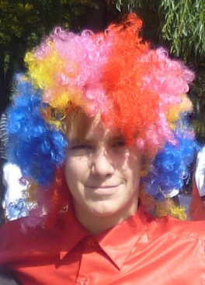

in it: sport competitions (Olympics, Winter Fun), dancing, playing computer games or work on a computer, writing an e-mail letter to her or his foreign pen-friend or taking part in making newspaper.
By Elena Kovtun

