Pupils speak: summer is over.

Hi! I’m a pupil of the sixth form of Pavlograd secondary school #7. I’d like to tell you about my last summer holidays. These summer holidays I spent in the countryside, I made new friends. We became good friends even three months, we have were few. We had goot time and great fun. Every day we went to the river and had wonderful relax on the nature, breathed fresh air and made the picnic. I and my friend Ann went to the center of the town saw variety of performances and famous singers and musicians.
That's how I spent my summer.
By Anastasia Pavlenko, 6B
My summer holidays were really great. There are some things that I like about school holidays. Firstly, I can wake up late in the morning, watch lots of TV programmes and play outdoors with my friends.
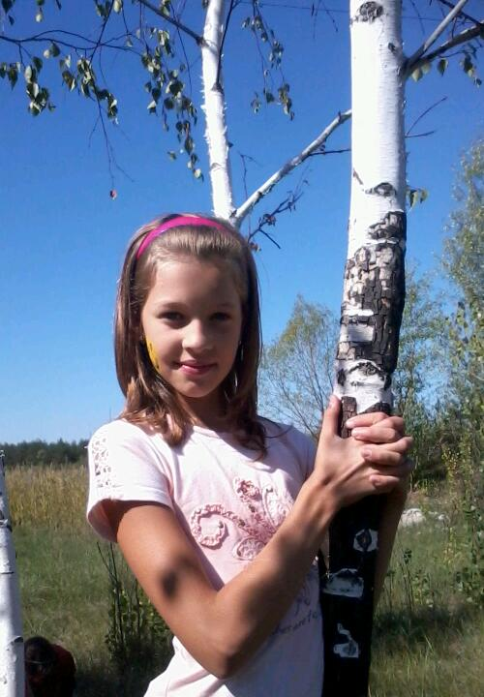

Also I can visit the Crimea and meet new friends. However, all school holidats are exciting. Finally, I can sunbathe and be happy.
There are some things that
don’t like about school holidays. To start with, I don’t
like to read a lot in summer. My mum always forces me read a lot in summer.
This summer I went to Crimea. I had trip to Yalta. I took a lot of photos and had good time.
My summer holidays were exiting!
By Marharyta Ktioka, 6B

My name is Sasha. I’m a pupil of the sixth form. In June I visited my granny. She lives in the village Serhiyvka. I played with my friends, fed hens, cows, ducks, rabbit and pigs.
In July I stayed home. When the weather was fine I stayed outdoors all day long and often helped my mother about the house. When the weather was rainy and nasty I played computer games.
In August my family went to Kyrylovka. We stayed there for a week. I bathed in Azov sea, sunbathed and went to the zoo. So, I had good time during my summer holidays and now I’m happy to back to school again.
By Oleksandr Dorofeev, 6B

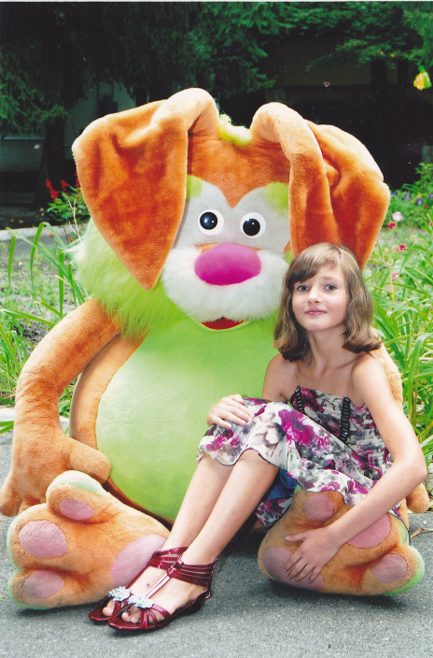

Schoolchildren have their holidays in June, July and August. My summer holidays were excellent and great fun.
In June my mother and I were in Chernomorsk. We stayed in a comfortable hotel near the sea. Firstly, we swam in the sea and laid in the sun. Secondly, we went to excursion to Ai-Petri. It was fantastic. Thirdly we were at the zoo. There were many exotic animals.
Finally, we visited some museums and learnt many interesting things. Furthermore, my mother and I bought souvenirs and presents for our relatives and friends.
In my opinion, I had the best summer holidays in my life.
By Illia Polishko, 6B
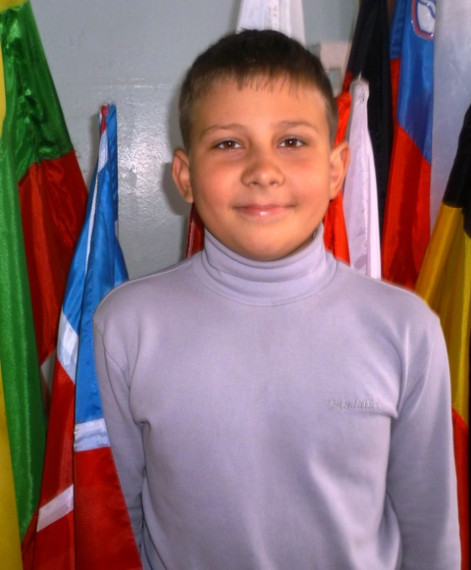

Sport news: traditional school Olympic Games.

I’ like to tell you about one of the most interesting school events - School Olympic Games. As for our school this holiday became traditional one. It’s held every year. All pupils from 5th to 11th forms went to the forest where they had sport competitions. They are wonderful and brought a lot of satisfaction to each participant.
I always try to take part in each competition and do my best. But the main aim is not to win. It is to find out well you can do some things.
In addition children should keep in mind that they should be in good physical form if they want to become successful in their life. They should also keep to a balanced diet, sleep enough and have healthy habits.
The motto of Olympic Games means: “Higher, better, stronger”

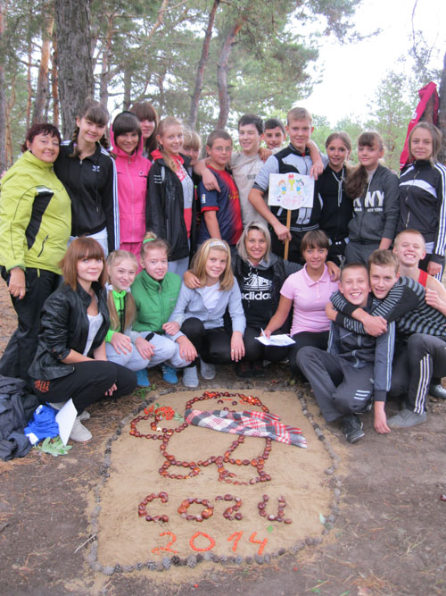

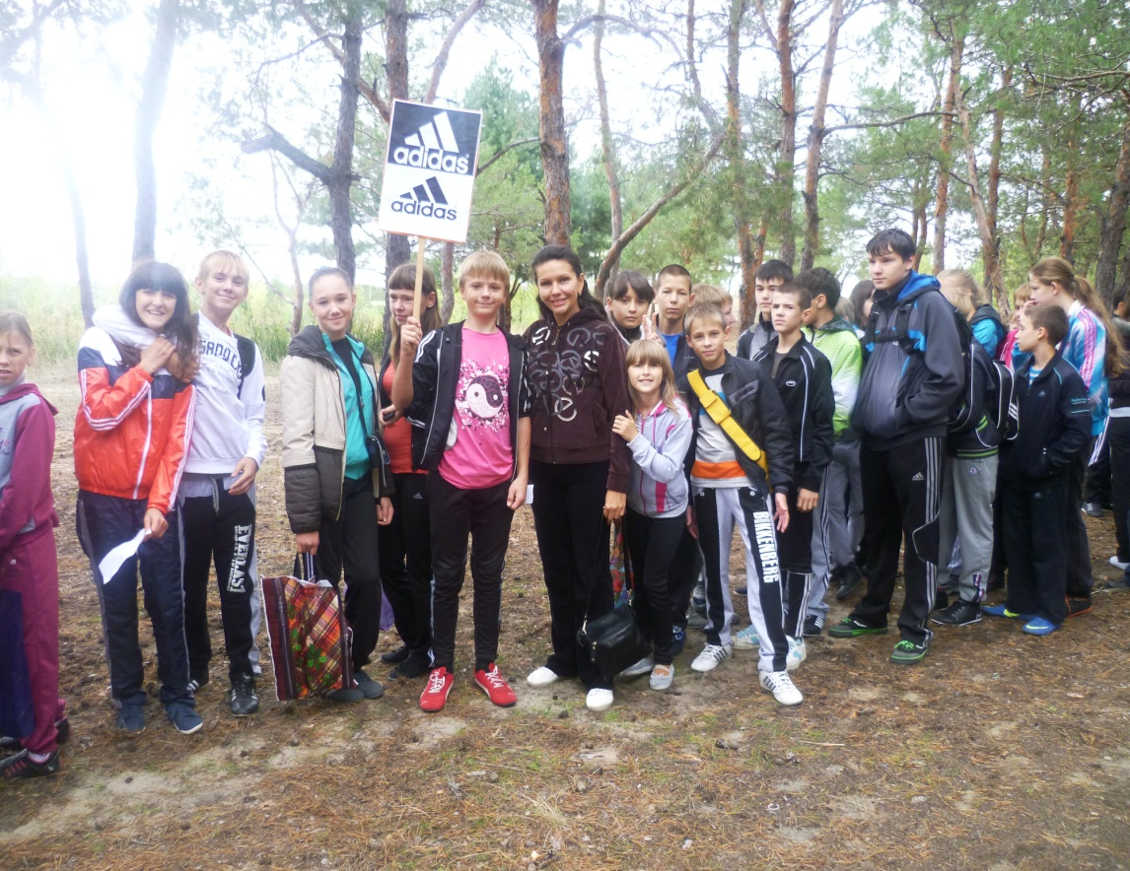

Health - most valuable treasure. Respect and taking care own health should be since childhood. School gives this opportunity. The 7th of September we dedicated sports. In fact, sport helps us to keep fit. We started it an Olympic lesson in which learned about various sports included in the official list, and how the Olympic Games are held.
Sport is one of the most activities to lead the health life. It helps us to keep fit. It is also necessary for children to grow up normally. During sport our muscles and lungs train and become stronger. Our heart becomes tough and we seldom are sick. In my opinion the main thing is to go in for sport for pleasure. You shouldn’t go in for sport till you drop. It won’t be useful but tiring.
By Yana Lebid’, 9 A

