Pupils speak

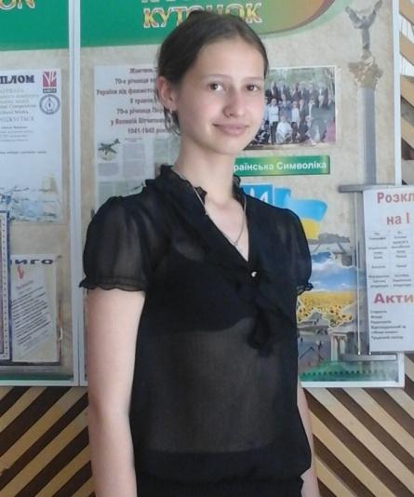

My Plans my for the future
After finished 9th form every student should choose whether to go to the 10th form or not. What occupation he or she should choose. It's very important choice which will affect on their future. This decision doesn't so easy to make. At first you must understand what school subjects you like most of all, then you need to organize in your interests. On the basis of all of this you need to choose your future occupation. I think each young people should listen to his/her parents but make the choice himself/herself because it's his/her life.
Only you can understand what the best is for you.
There are many mines in our town, that’s why boys often becomes miners and girls - accountants, secretaries, sellers and others women's occupations. I don't divide the professions at the women's and men's, I think that many occupations fit both boys and girls.
So you need to be based only on your wishes and goals. There are huge number of possibilities and everybody will find them. You just need to think for a

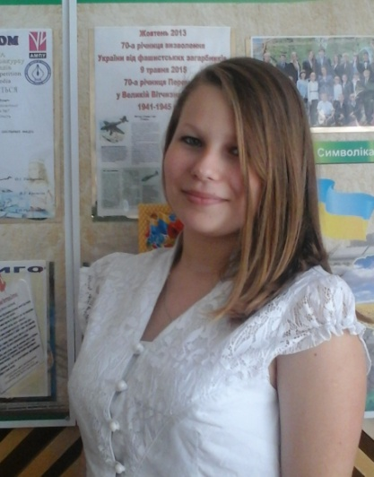

while, weigh the pros and cons, and consult with your parents,
so you will understand what YOU want.
By Tetiana Lukerievas , 9A
What I want to do after 9th form.
Choosing a profession - it is a big responsibility. The responsibility of the parents, the community, and most importantly - ourselves. Responsibility to each other, perhaps the most important, and it is to choose just your way and keep it. For only the people can see what it greater ability to feel what it call. Everyone feels that it is easier to "given" and, therefore, why can devote his
life. And then the most important thing - not err.
I have chosen future profession, guided by many factors, but most important of them was that this work I feel called to do. I have always been indifferent to the fate of people like my family, so quite strangers to me has always meant a lot of concepts such as "fairness", "justice", "human rights." That is why I have chosen for themselves the legal profession and going after higher education to be a lawyer.
By Kateryna Huchanova , 9A

My name is Maxim Kozorog. I will finish school very soon.
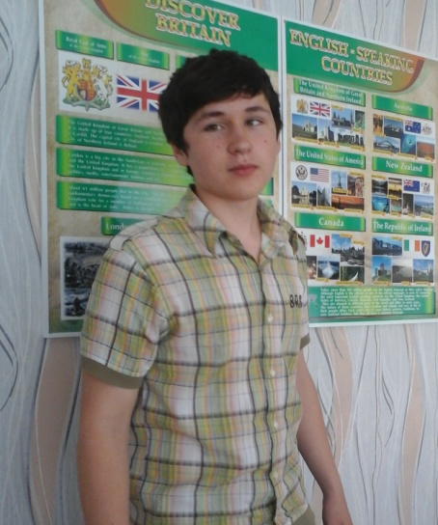

Very important step.
Very soon a very big and important part of my life will be over. I am leaving the 9th form, and the closer it gets the more thoughts and recollections come to my mind. It is the period of my life, when I have to choose the future profession.
I think that to be a historian is also very important today.
People think that it is possible to live without looking back at the

historical past. But it is a mistaken view. We cannot live without history because it is around us. By analyzing the past we can avoid the mistakes in the future. If people do not use the experience of the past they will inevitably make mistake in the present. Historians have always tried to understand past human lives and societies. History helps to understand the global historical process. Historians interpret the processes of the past to explain the processes of the present and foresee the processes of the future.
By Mykola Horhola , 9A

My crazy dreams.
I want to be a cyber sportsman or cooker. But in my town I can be only a miner because they receive a good salary for their work. I don’t like this idea but I love money.
I want to be a cyber sportsman because I like to play computer game all day long. It’s very interesting to travel all over the world and play on championship. They earn much money but you must be a first in this game.
I want to be cooker because I like to cook some delicious food for my family or friends. I do not know what salary they receive. I don’t care about this. I like to teach something new in cooking. Unfortunately these are only a dreams
I think I will be a miner. It`s sad story.
By Maxim Kozorog , 9A
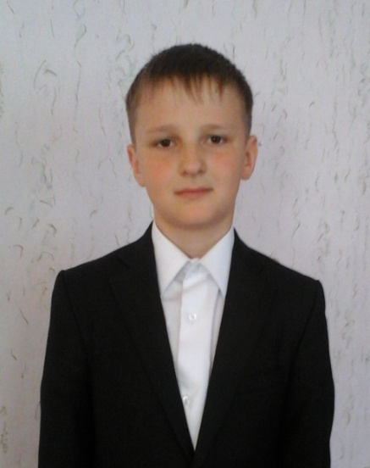

The USA
There are 50 states in the United States of America. Washington, D.C. is a capital city of the USA. Washington, D.C. is the only community in the whole country that is not located in a state. The capital city is a little more than 200 years old. The main building is the Capitol. It is well-known for

its rotunda, or a round room. This round room has a large
dome. The Statue of Freedom stands on top of the dome. There is also the White House, the Lincoln Memorial and other places of interest in the capital.
By Mikhail Teriokhin , 6B

Climate and Nature of the USA

The USA is situated in the central part of the North American Continent. It is washed by the Atlantic Ocean in the east, by the Pacific Ocean in the west and by the Gulf of Mexico in the south. The climate varies from moderate to subtropical continental. Along the Pacific and Atlantic coasts it is oceanic.
Most of the USA territory is marked by sharp differences between winter and summer. Average winter temperature is about 25 degrees below zero in Alaska and up to 20 degrees above zero in Florida. Average summer temperature varies from 14 degrees above zero in the western part and up to 32 degrees above zero in the southeast. The largest amount ofrainfall is noted in
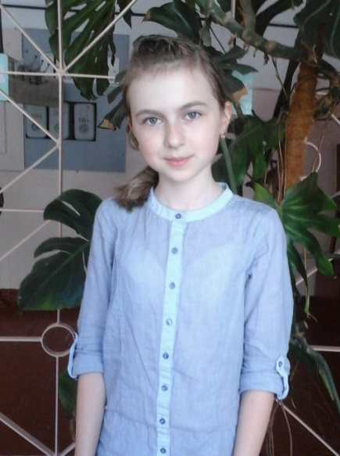

Alaska and the southwest of the country. In
winter the northern part of the USA usually has a steady snow cover.
The largest rivers of the USA are the Mississippi, the Missouri, the Yukon, the Columbia, and the Colorado. The Great Lakes are situated in the northeast of the country. The region of the Cordilleras has semideserts, while the rest of the territory is rich in forests.
In California, where the climate is usually mild, the famous fruit-raising area is located. Californian oranges, grapefruit and lemons are sold all over the USA and other parts of the world
There are a lot of national parks in the USA, the aim of which is to preserve the beauty and treasures of the nature.
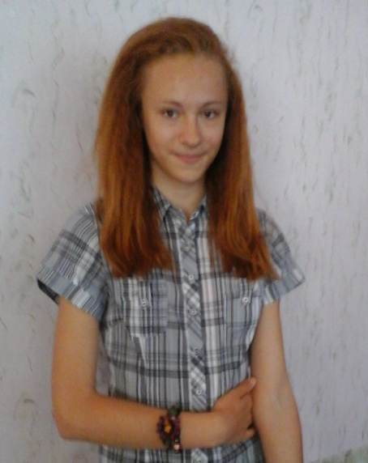

By Rateryna Kolomoets , Anna Halenko, Anastasia Pavlenko,6B

