Just for fun: primroses festival

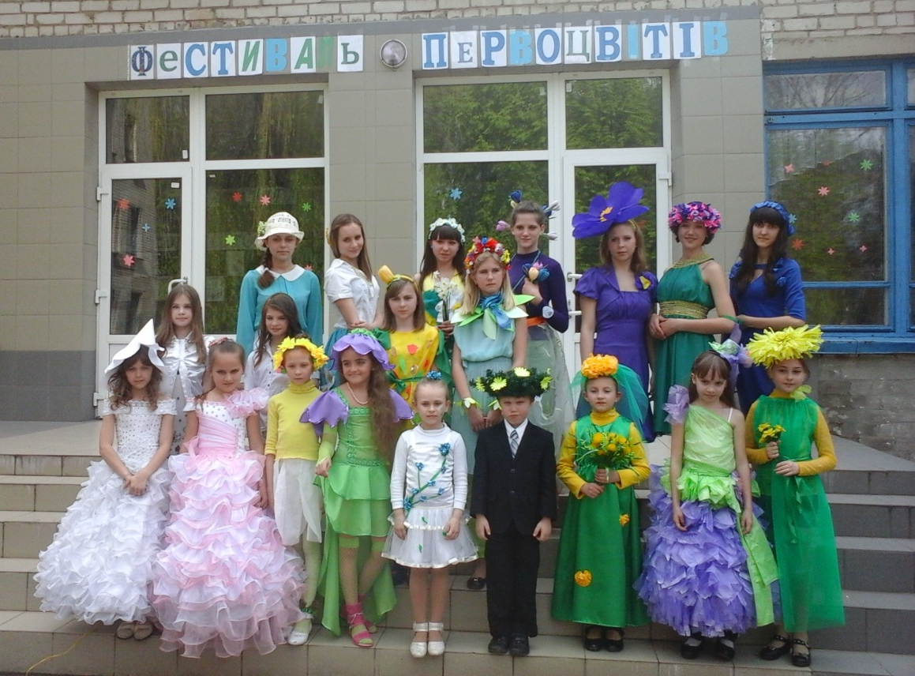
The Primrose (Primula vulgaris) is a low to the ground herb that flowers. It is found mainly in western and southern Europe including Britain. It is also known as the Common Primrose and the English Primrose. Primrose Day was a special day in memory of British Prime Minister, Benjamin Disraeli (Lord Beaconsfield), who died on 19 April 1881 . England's Primrose day sprang from a friendship between Benjamin Disraeli and Queen Victoria. They were brought together through their love for their country (patriotism).
By Tetiana Ehorova , 7A
our correspondents; Eurovision Song Contest

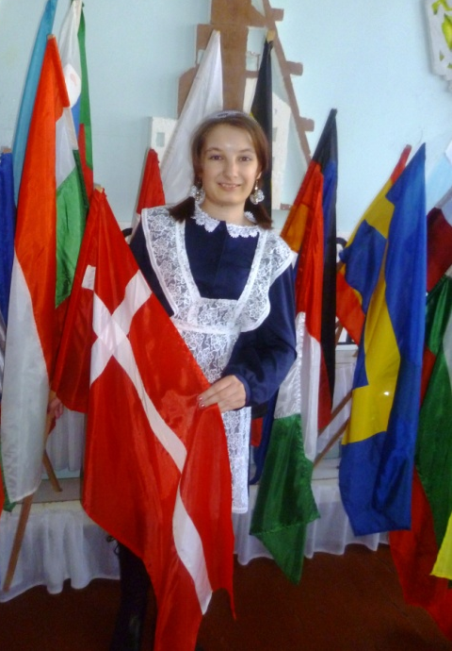

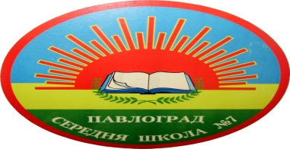

I watch the Eurovision Song Contest since 2007 - is a magical action that unites different countries in love of music, the song, the beauty. Like Eurovision that felt the greatness of what is happening, sorcery and magic songs.
In 2014, the contest will be 6, 8 and 10 May in the capital of Denmark - Copenhagen city, because in 2013 victory won spokeswoman Denmark Emilie de Forest with the song «Only teardrops». I am very pleased with this song . More Emilie de Forest was invited to the Junior Eurovision, which in 2013 was held

Editor: English teacher Elena Kovtun
Creative group: Ekateryna Kolomoets,Olha Kudrytska, Tetiana Lukerievas, Mykola Horhola, Kateryna Huchanova, Tetaina Yehorova, Anastasia Pavlenko

on November 30 in Kiev ! I really wanted to go to Kiev and ask for her autograph , but I did not succeed . Won at Junior Eurovision representative Malta , Gaia Cauchi with the song «The start», a representative of Ukraine Sophia Tarasova won 2nd place .
Contest held since 1956 , Ukraine will take part in the competition since 2003, has good results , but won just one time in 2004. Then victory Ruslana won with the song «Wild dance».
By Olha Kudriytska , 11A

Dnepropetrovsk, Pavlograd
Phone: (056) 32-3-01-57
e-mail: sc_7_pv@ukr.net

I S S U E # 9

- What can we read in this issue of “School Rainbow”?

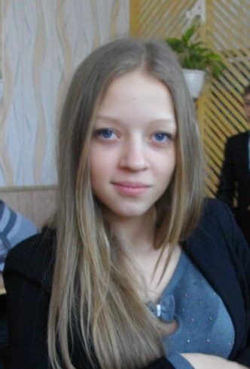
You can read in this issue of “School Rainbow about different events from our school life. You’ll read about dreams of our 9th formers, what know 6th formers about USA and school primroses festival.

V International Exhibition "Modern Educational Institutions - 2014"

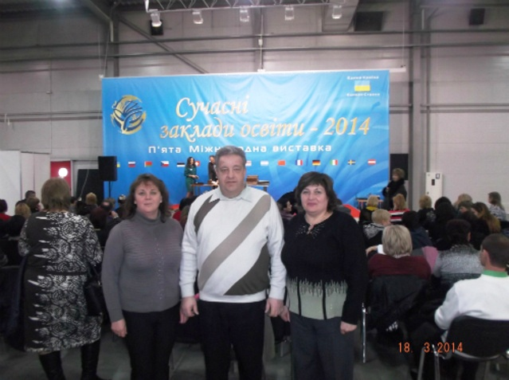

the best workbooks and day books; the Methodical living room;

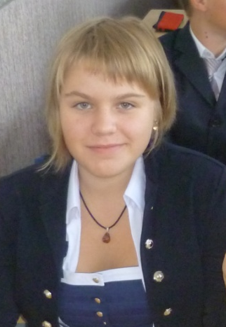

18-19 March 2014 the delegation of our school took part in V International Exhibition "Modern Educational Institutions - 2014" held in Kiev.
Dnipropetrovsk Regional Institute for Postgraduate Education received the award for winning the contest exhibition Rating and our school - Diploma for presentation of advances in innovative modernization of national education. During the exhibition days working scientific conferences, round tables, workshops with modern technology in education, seminars, exhibitions, shows. Reviewing exposure and competition graduate students get creative works pleasant moments of communication with the world of beauty.
By Elena Kovtun

