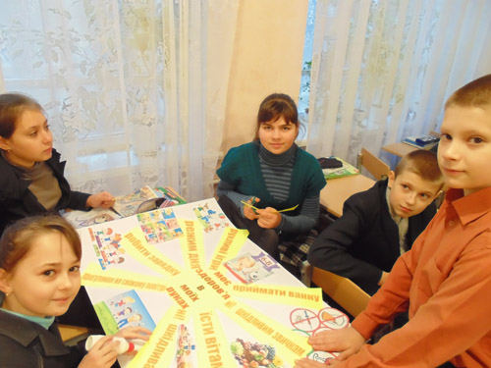
School newspapers contest "My future - in my hands" between the students of 5th -11th form.

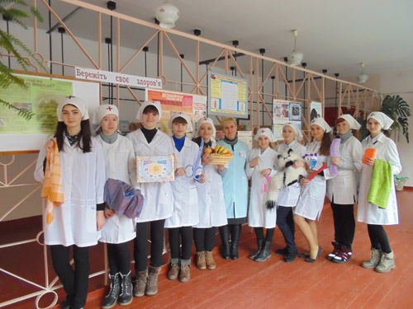

Action “Sanitary Bulletins are Informing”.

Dance and Acrobatic program in support of Physical Education and Sport.

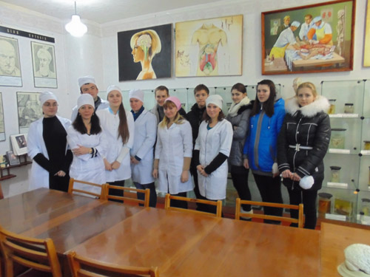

The students of 9th form who are visiting the museum of Medical School

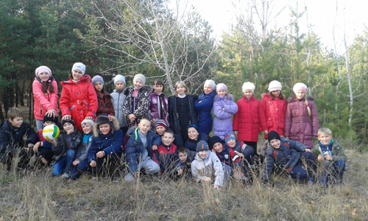

To the Nature for Health!

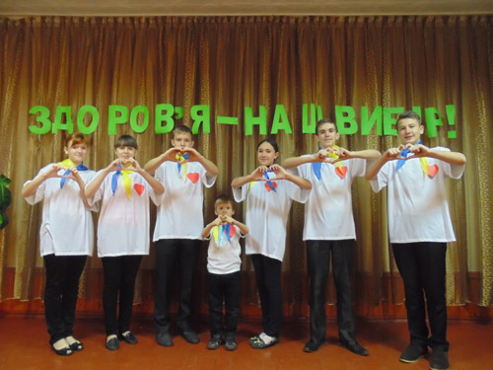

The Performers of Propaganda Team “MIX”

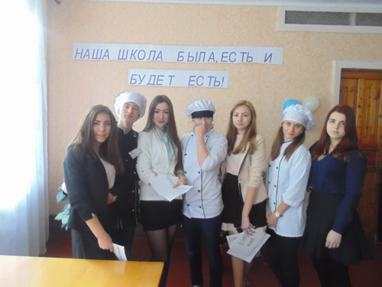

Canteen Day “Our school ate, eat and will eat”.

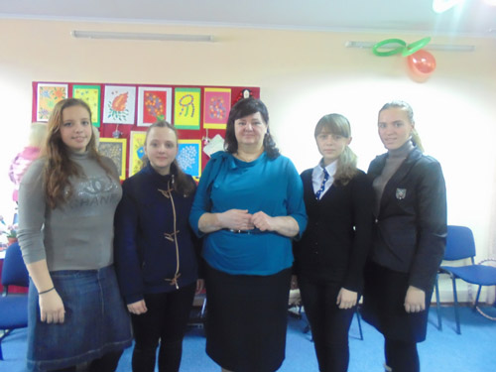

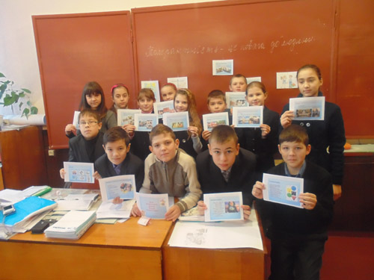

Tolerance is a Respect for a Man.

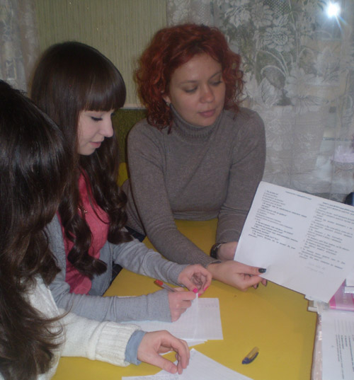
A school parliament visited the "School Irene", personally met with the founder of the school and watched the exhibition of children with special needs.

Monitoring the situation of alcoholism and smoking among teenagers.

