our correspondents: Natural disasters .

Description a natural disaster is a result of a natural hazard, which has a negative effect on human beings. These geologic processes can lead to serious consequences such as loss of life, property damage, and economic problems. Certain areas are more exposed to natural disasters. For example, most of New Zealand’s coastline is exposed to tsunami hazard, while the Far East region is exposed to floods. Being aware of possible dangers, people should be prepared to protect themselves, their families and communities. Violent floods, storms, wildfire or earthquakes are frightening even for adults. Natural disasters can be especially dramatic for children.
BY Kateryna Huchanova, 10A

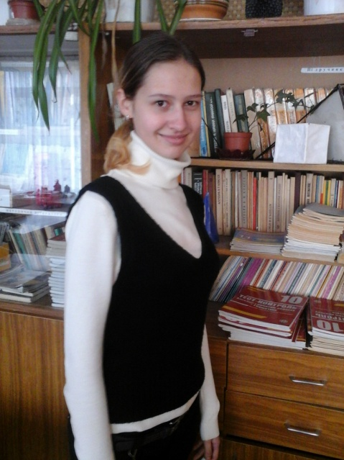

Tornado happens very often in America. Tornado is a very strong wind that moves very fast in a circle. Tornado destroys the whole towns in the cast. Some people die and many houses are broken. People try to help each other. Money, clothes, foods are prepared for those in need. Tornados are frightening even for adults, and can be especially dramatic for children.
By Tetiana Lukerievas, 10A

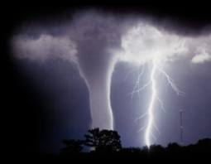

Editor: English teacher Elena Kovtun
Creative group: Ekateryna Kolomoets, Tetiana Lukerievas, Mykola Horhola, Kateryna Huchanova, Vladyslav Ulan, Vadym Fandiy

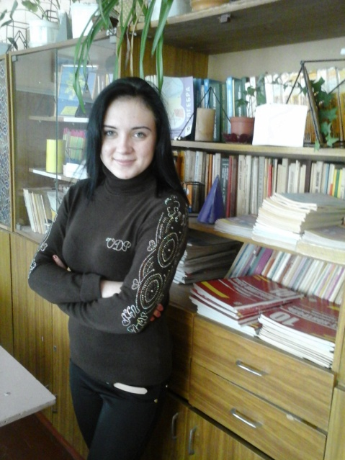

Natural disasters are extreme, sudden events caused by environmental factors that injure people and damage property. Earthquakes, windstorms, floods, and disease all strike anywhere on earth, often without warning. As examples, we've chosen disasters that have occurred around the world throughout history.
Flood is a natural disaster. For people, who are directly affected by it, it can be devastating. There are several reasons for floods. One of them is excessive raining. At other times it is caused by the overflow of rivers or dam breaks. At any case it has negative outcomes, which lead to environmental and economic loses
By Aliona Kotsenia, 10A

Dnepropetrovsk, Pavlograd
Phone: (056) 32-3-01-57
e-mail: sc_7_pv@ukr.net

,

Англомовна газета Павлоградської загальноосвітньої школи І – ІІІ ступенів № 7

I S S U E #11

-Of course! You can’t even doubt. There were a lot of interesting extraordinary events in February and December. You can read about them in this issue of our newspaper.

Our holidays: The new year’s Day.

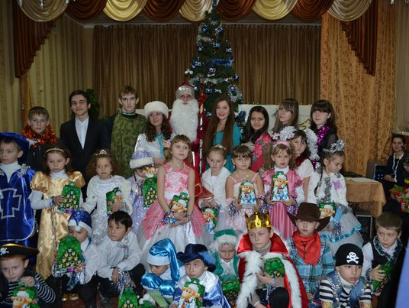
New Year is the most long-awaited holiday. Many people associate it with magic and gifts. First of all it is surrounded by the wonderful smell of tangerines and Christmas trees, which helps to create a festive mood. People of all ages truly believe that in New Year their goals and wishes will come true.
We always look forward to the New Year parties at our school. This is bright and unique event with involving all school students. This year wasn’t exception to the rule.
Everyone enjoyed and had good mood for the winter holidays.
Merry Christmas and Happy New Year!
By Catherine Kolomoets, 7B

- Is there any interesting information in this issue?

-Why “School Rainbow”
-Why “School Rainbow”

